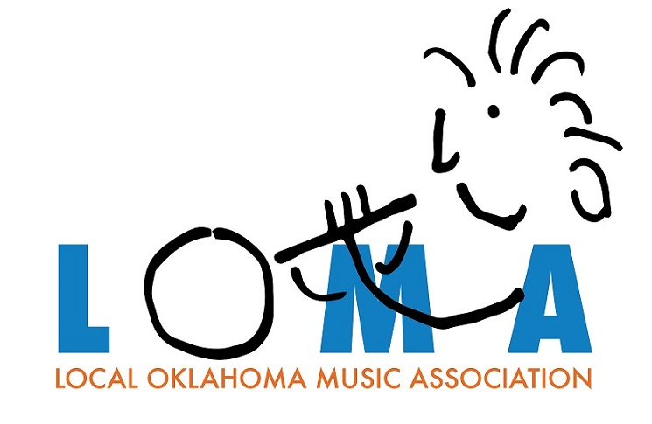
LOMA is a 501-3c non-profit corporation whose purpose is to provide financial aid to local elementary and secondary school music programs with financial aid for instruments, instrument repairs, print & electronic music, equipment, student fees, and supplemental teachers or clinicians.

LOMA operates under the guidance of its five member board. Current officers and board members are Brian Lamb President, Doug Henderson Secretary, Mike Gilliam Treasurer, Brian Britt and Mark Parker.

LOMA is currently accepting donations and will have a fund raising raffle starting in September 2019. 100% of LOMA’s donations and raffle proceeds will go to the local music programs to fund the purchase or repair of musical instruments & equipment and/or the purchase of music.

LOMA’s website, loma.rocks, will be up and running by September 1st. Until that time, contact Mike Gilliam at 850-4222 with any questions.

LOMA P.O. Box 8752 Edmond, Oklahoma 73083

